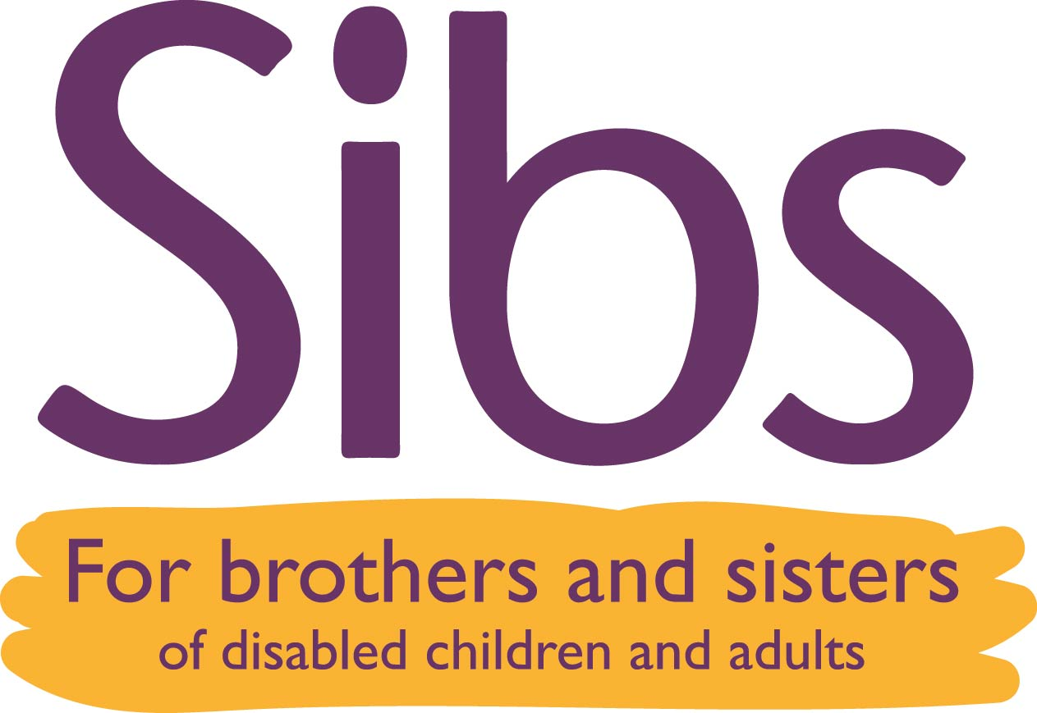

Sibs safeguarding adults at risk policy

Definitions of adults at risk
Sibs recognises that there are different definitions of the term ‘adult at risk’ in England, Wales, Scotland and Northern Ireland. Please see Appendix 1 for these definitions.

What is abuse?
‘Abuse’ means to treat someone badly. Abuse is often intentional and can happen in many different forms, however some abuse is unintentional. Abuse, harm and neglect of adults at risk may be defined differently in England, Wales, Scotland and Northern Ireland. Some types of abuse are also criminal offences. Please see Appendix 2 for further resources.

Who might abuse?
Someone known to the person – a family member, spouse, friend, colleague, paid carer or staff, volunteer, religious leader, teacher, professional.
Someone not known to the person – a member of the public, visitor, bank staff.

Where might abuse happen?
In the person’s own home, in the home of a friend or family member, place of work or volunteering, day service, care home, hospital, college, university, or in any public place.

Types of abuse
- Types of abuse may include: Physical, sexual, emotional/psychological, financial/material, neglect, self-neglect, modern slavery, domestic abuse, discriminatory abuse, institutional abuse
- Other terms to be aware of include: hate crime, mate crime, online harm, scams/fraud, radicalisation
- Read examples and symptoms of each type of abuse and harm at www.sibs.org.uk/safeguardingadults as this resource is updated at least annually

Remember:
- This list is not exhaustive – you may come across other types of mistreatment
- Several types of abuse may happen at once
- Possible signs are not necessarily hard evidence that abuse is happening, but they are an indication that further investigation needs to take place

Policy statement
- Sibs is fully committed to safeguarding the welfare of adults at risk
- Sibs believes that safeguarding adults at risk is everyone’s responsibility. It is a responsibility present in every aspect of our work with adults
- Sibs believes that adults at risk should be valued as individuals, be treated with dignity and respect, be cared for and be safe
- Sibs is fully committed to promoting the welfare and safety of all who come into contact with its staff and volunteers, regardless of age, disability, gender reassignment, marriage and civil partnership, pregnancy or maternity status, race, religion or belief, sex or sexual orientation – their protection from harm is a key priority for Sibs

Sibs will ensure that its staff and volunteers:
- Have a full understanding of adults at risk and how to recognise abuse
- Follow the adults at risk safeguarding procedure
- Ensure that adult siblings and others who are concerned about abuse of adults at risk know what safeguarding action to take and that they are sent the information on our safeguarding adults page www.sibs.org.uk/safeguardingadults

In working with other agencies Sibs will:
- Work in partnership in order to protect adults at risk
- Work towards a professional culture of openness and co-operation. All staff and volunteers are made aware of the responsibilities appropriate to their roles and those of others.

Where this policy applies in Sibs
- At Sibs workshops, conferences and other events whether these are in person or online
- On the Sibs telephone and email helpline
- In Sibs work with adult sibling support group facilitators
- In any other Sibs work

People to whom this policy applies
- All Sibs paid staff (salaried and freelance)
- Sibs trustees
- Sibs volunteers

Roles
A named Trustee should take responsibility for leading on safeguarding issues
- The Trustee board will ensure that the roles outlined in this section are being undertaken in accordance with these procedures
- The Trustee board will ensure that an appropriate safeguarding induction, support and training programme is in place and implemented
- The Trustee board will ensure that recruitment procedures safeguard the welfare of any adults at risk and are implemented

Clare Kassa*, CEO of Sibs is the designated safeguarding lead. She will ensure that:
- The safeguarding policy is implemented and adhered to at all times
- Sibs is up to date with all relevant legislation
- Liaison is carried out with local authorities as and when necessary
- Appropriate training and support is arranged for all staff in contact with adults
- Support is provided to workers during and after incidents involving safeguarding and referrals to social care or the police
- Sibs chair of trustees, Jackie Howes (Vice-Chair), is the safeguarding lead on the board of trustees

All Sibs workers are responsible for:
- Adhering to the policies in this document
- Reporting any incidents or concerns to the CEO
- Reporting concerns in other settings e.g. local authorities to the person responsible for safeguarding
- Following the Sibs procedure for acting on concerns
- Discussing safeguarding issues and best practice in one-to-one sessions with their manager
- Attending induction and ongoing training in safeguarding
*Contact Clare: clare@sibs.org.uk

Updated Feb 2025

Appendix 1
Definitions of ‘adult at risk’:

England
“(a) has needs for care and support (whether or not the authority is meeting any of those needs),
(b) is experiencing, or is at risk of, abuse or neglect, and
(c) as a result of those needs is unable to protect himself or herself against the abuse or neglect or the risk of it.”

As defined in the Care Act 2014, England.

Wales
“(a) is experiencing or is at risk of abuse or neglect,
(b) has needs for care and support (whether or not the authority is meeting any of those needs), and
(c) as a result of those needs is unable to protect himself or herself against the abuse or neglect or the risk of it.”

As defined in the Social Services and Well-being Act 2014, Wales

Scotland
“(1) “Adults at risk” are adults who—
(a) are unable to safeguard their own well-being, property, rights or other interests,
(b) are at risk of harm, and
(c) because they are affected by disability, mental disorder, illness or physical or mental infirmity, are more vulnerable to being harmed than adults who are not so affected.

(2)An adult is at risk of harm for the purposes of subsection (1) if—
(a) another person's conduct is causing (or is likely to cause) the adult to be harmed, or
(b) the adult is engaging (or is likely to engage) in conduct which causes (or is likely to cause) self-harm.”
As defined in the Adult Support and Protection Act 2007, Scotland.

Please note: In Scotland, a child legally becomes an adult when they are 16 years old. Statutory guidance which supports the Children and Young People (Scotland) Act 2014, includes all children and young people up to the age of 18 years old. Where a concern is raised about a 16 or 17 year-old, the relevant agencies involved will need to consider which legislation to follow given the age and the circumstances of the person at risk.

Northern Ireland
“An ‘Adult at risk of harm’ is a person aged 18 or over, whose exposure to harm through abuse, exploitation or neglect may be increased by their:
- personal characteristics
AND/OR
b) life circumstances
Personal characteristics may include, but are not limited to, age, disability, special educational needs, illness, mental or physical frailty or impairment of, or disturbance in, the functioning of the mind or brain. Life circumstances may include, but are not limited to, isolation, socio-economic factors and environmental living conditions.”

In Northern Ireland, there is no specific legislation that underpins adult safeguarding. The above definition is taken from Adult Safeguarding: Prevention and Protection in Partnership, a policy published in 2015 jointly produced by The Department of Health, Social Services and Public Safety (DHSSPS) and the Department of Justice (DOJ).

Appendix 2
Definitions of ‘abuse’:

England
Refer to Ann Craft Trust for descriptions of abuse and neglect that relate to the Care Act 2014, and other types of harm that are not covered by the act but that relate to safeguarding.

Wales
Refer to pages 7 – 9 of Social Services and Well-being (Wales) Act 2014: Working Together to Safeguard People Volume I – Introduction and Overview for definitions and examples of abuse and neglect.

Scotland
Refer to Act Against Harm for descriptions of financial, physical, psychological and sexual harm, and neglect (including self-neglect) that relate to the Adult Support and Protection Act 2007.

Northern Ireland
Refer to pages 11-15 of Adult Safeguarding: Prevention and Protection in Partnership, for definitions of harm, abuse, and related terminology.

Note that the policy does not include self-harm or self-neglect within the definition of an ‘adult in need of protection’, and these cases would be considered on an individual basis by the Health and Social Care Board.

In Northern Ireland, there is no specific legislation that underpins adult safeguarding. Adult Safeguarding: Prevention and Protection in Partnership, is a policy published in 2015 jointly produced by The Department of Health, Social Services and Public Safety (DHSSPS) and the Department of Justice (DOJ).

