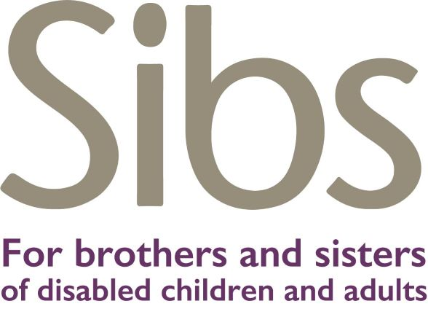

Sibs’ child safeguarding policy

Policy Statement
- Sibs is fully committed to safeguarding the welfare of children and young people (under 18)
- Sibs believes that safeguarding young people is everyone’s responsibility. It is a responsibility present in every aspect of our work with children, young people and their families.
- Sibs believes that children and young people should be valued as individuals, be treated with dignity and respect, be cared for as a child first, and be safe.
- The welfare of every child and young person in contact with the services provided by Sibs remains paramount at all times. This principle is the central tenet of the legislation for children’s protection in each of the four UK countries. For legislation and relevant reporting requirements see https://www.nspcc.org.uk/preventing-abuse/child-protection-system/
- Sibs is fully committed to promoting the welfare and safety of all who come into contact with its workers, regardless of age, disability, gender reassignment, marriage and civil partnership, race, religious belief, sex or sexual orientation – their protection from harm is a key priority for Sibs.

In working with other agencies Sibs will:
- Work in partnership in order to protect young people
- Work towards a professional culture of openness and co-operation. All workers are made aware of the responsibilities appropriate to their roles and those of others.

In working with young siblings Sibs will:
- Help children and young people to be responsible in their approach to e-safety
- Ensure that its policies and procedures are accessible and understandable to all young people who use YoungSibs
- Ensure that we operate in line with our values and within the law in terms of how we use information technology

Where this policy applies in Sibs
- At Sibs conferences where young siblings attend
- At regional consultation events for young siblings
- At Sibs workshops
- On the Sibs telephone and email helpline
- In any other Sibs work with young siblings

People to whom this policy applies
- All Sibs paid staff (salaried and freelance)
- Sibs trustees
- Sibs volunteers

Roles
A named Trustee should take responsibility for leading on safeguarding issues
- The Trustee board will ensure that the roles outlined in this section are being undertaken in accordance with these procedures
- The Trustee board will ensure that an appropriate safeguarding induction, support and training programme is in place and implemented
- The Trustee board will ensure that recruitment procedures safeguard the young people’s welfare and are implemented

Clare Kassa* CEO of Sibs is the designated safeguarding lead. She will ensure that:
- The safeguarding policy is implemented and adhered to at all times
- The policies reflect all relevant legislation
- Liaison is carried out with Child Protection Agencies as and when necessary
- Appropriate training and support is arranged for all staff in contact with young people
- Support is provided to workers during and after incidents involving safeguarding and referrals to social care or the police.
- Sibs vice-chair of trustees, Jackie Howes, is the safeguarding lead on the board of trustees.

All Sibs workers are responsible for:
- Adhering to the policies in this document
- Reporting any incidents or concerns to the CEO
- Reporting concerns in other settings e.g. schools to the person responsible for safeguarding
- Following the Sibs procedure for acting on concerns
- Discussing safeguarding issues and best practice in one to one sessions with their manager
- Attending induction and ongoing training in safeguarding.
Reviewed annually *Contact Clare via our contact form www.sibs.org.uk/contact/ or on 01535 645453.

YoungSibs online safety policy and procedures

This document should be read alongside Sibs Child Protection Policy and Sibs Acting Upon Concerns Procedure. The same safeguarding principles apply to online safety.

Sibs will seek to keep children and young people safe online by:
- Appointing an e-safety co-ordinator
- Incorporating statements about safe and appropriate website use and online behaviour into the codes of conduct for staff and volunteers
- Reviewing and updating the security of our information systems regularly
- Ensuring that service users names or identifying details are not used on the YoungSibs website
- Providing effective management for staff and volunteers on ICT issues and online behaviour through supervision, support and training.

Working with third parties and contractors
There may be occasions when third parties require access to the data kept on the YoungSibs site for web maintenance and construction purposes. In these circumstances, to ensure that the data is kept secure and puts neither the users nor the organisation at risk, the following procedures should be followed.
- The third party must confirm that their internal security processes are compliant with those required by the Data Protection Act. This means that they must have appropriate security measures in place to prevent unauthorised access to, or unauthorised alteration, disclosure or destruction of, the data and against their accidental loss or destruction.
- Only one named member of staff should access to the personal data of the users
- This member of staff must undergo a DBS check
- An agreement must be signed to confirm the above measures are in place prior to any contracting arrangements being finalised.

Staff procedures for working on YoungSibs

Logging on and password safety
- Ensure that the password used to log on the YoungSibs site is kept securely
- When using Wi-Fi ensure that it is password protected
- Do not use public Wi-Fi to log on to the YoungSibs site

The current e-safety co-ordinator is Linda Owen, Information Officer for YoungSiblings
Tel 01535 645453 Email linda@sibs.org.uk August 2023
Sibs risk assessment form for children and young people

1. Details of this risk assessment
First completed on
by (worker's name)
Most recently updated on
by (worker's name)

2. Details of the young person
Young person's name / username(s):
Young person’s email address:
Contact details, if known and relevant:
Any other details:

3. Risk identified
Date concern received?
How was the concern received? (email, phone)

What gave cause for concern? Cut and paste entire message or significant sections of transcript (or attach transcript and summarise here)

What potential harm could occur?

How serious is this harm? (mark with an X)
Significant |  |  |  | Serious |  |  |  | Fatal |  |  |  | Unknown
What is the likelihood? (mark with an X)
Remote |  |  | Possible |  |  |  | Likely |  |  | Certain |  |  |  | Unknown

What protective factors are present?

What needs to happen to keep the young person safe?

What actions will be taken? (e.g. agencies referred to)

What advice was given to the young person? Cut and paste entire message or significant sections of transcript (or attach transcript and summarise here)

Date information shared with CEO:

Updates - copy and paste the following table for each update. Note the most recent date in the box at the top of page 1.

Date of update:
Feedback from referral agency (if applicable):
New information from young person:
Further action taken:
Advice given to young person:

Sibs safeguarding children – acting on concerns procedure
